From the Principal

Morning Routine

Just a reminder to parents who drop off their children at school in the mornings, that the teachers start their duty at 8:30am. If you are at school before this time you are responsible to look after your children. In the mornings, the pedestrian gate (to the bus bay) will be open, however, the bus bay gates will remain closed until approximately 8:30am.

Gates at front of School

The front gates of the school are unlocked for pedestrian use throughout the day, however we ask that anyone who uses the gates to please close them immediately after entering as we have a number of students who look for opportunities to abscond.

Presentation Day

I would like to encourage everyone to come to our Presentation Day Assembly next Tuesday. From what I have heard and seen it will be a very entertaining and rewarding event. Also, remember that all guests are invited back to the school for light refreshments after the Assembly.

Katrina Eyland
School Principal

Up and Coming Events
Term 4 Week 9
2 Dec Presentation Day Assembly 11:30
3 Dec International Day for People with a Disability
Term 4 Week 10
8 Dec Bowling Excursion
Term 4 Week 11
17 Dec Last day of school

RAP Awards
(Really Awesome Person)
Congratulations to the following students who received RAP awards.

1P Daniel, Kaylen, Damian
2P Tim, Faith, Shayden
3P Ashlyn, Charlee
4S Zeke, Joshua, Declan, Buddy, Tobias, Eamon
5S Magenta
6S Kayla, Shae-Lynn, Clayton, Joshua, Isabel, Dominic, Shiun, Holly

Community News




Shoalhaven Disability Forum would like to invite you to come join in the celebrations for International Day for People with a Disability

When: 3rd December 2014

Where: Junction Court, Nowra

Time: 10am to 1pm

Raffle: Money raised from the raffle will
be donated to Variety the children’s charity

Entertainment: Local Musician’s, Buskers

Activities: Cupcake Stall, BBQ, Giveaways,


Variety Bash Car, Coffee Van, Baby Lamb, Surprise Celebrity

General inquiries: to Karen (02) 44293411

SHOALHAVEN CITY COUNCIL

Grandparents Raising Grandchildren Resource Guide

Grandparents Raising Grandchildren Resource Guide has recently been developed by Council in response to the increasing number of grandparents raising grandchildren in the Shoalhaven.
The Grandparents Raising Grandchildren Resource Guide is available on Council’s website www.shoalhaven.nsw.gov.au
or contacting Karen Denny, Community Development Officer Aged & Disabled, Corporate & Community Services Group on 44293446.



FREE TO A GOOD HOME

Contact the school office on 44213777.

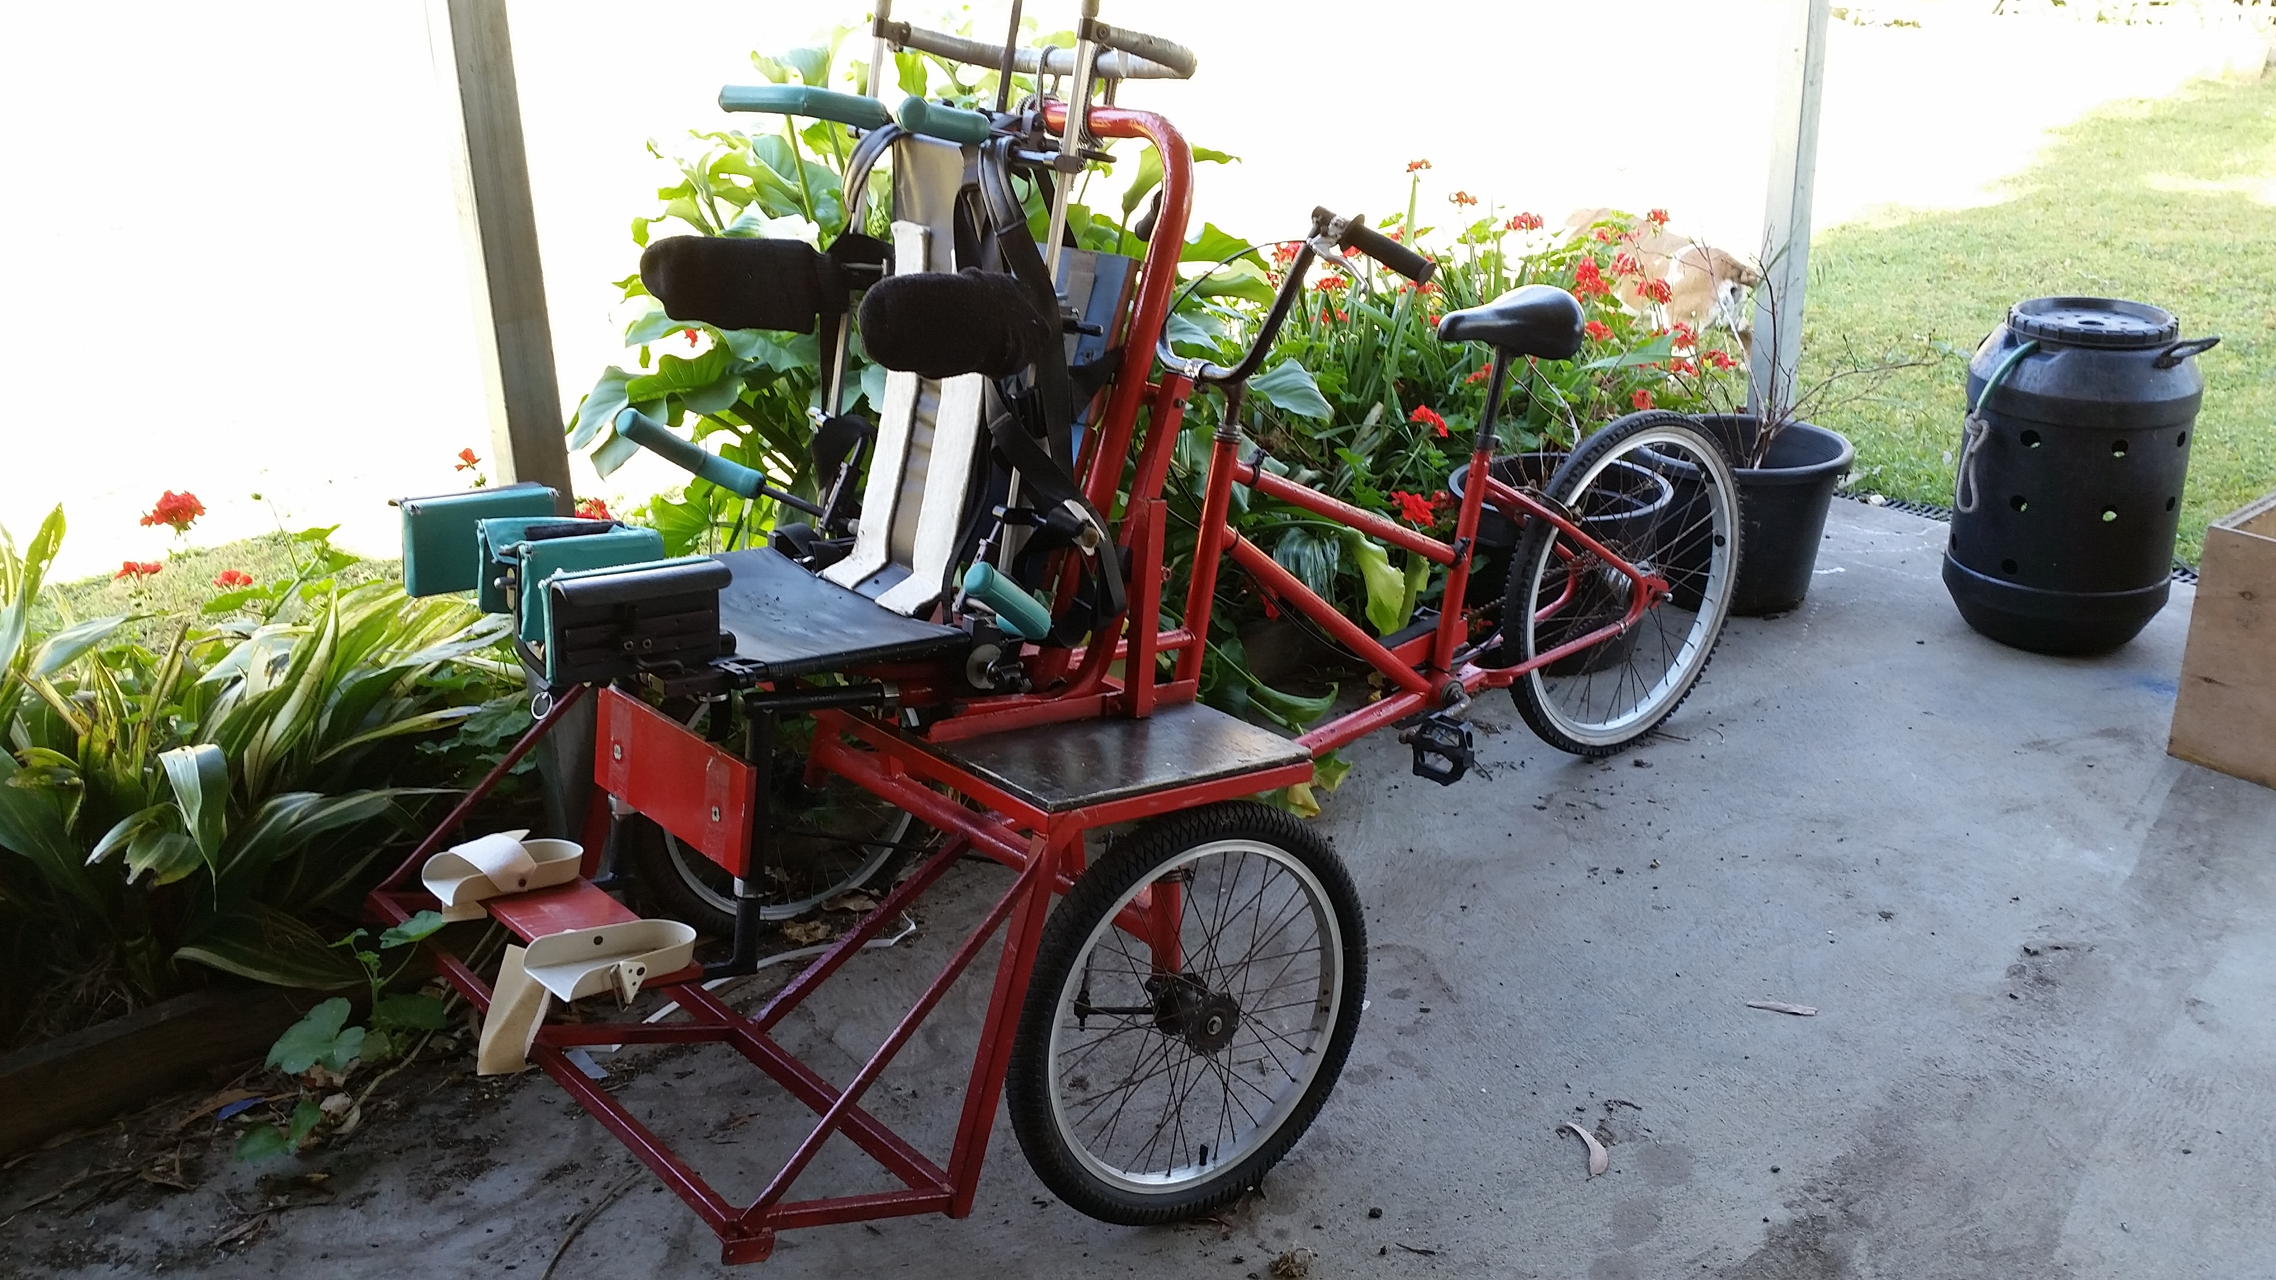


Where: Bomaderry RSL,
When: 6/12/14
Time: 6.30pm must be over 18yrs
Entertainment: Live Bands, Raffles, Win a Guitar
Drifting Doolagahls
Double Barrell
Jenno Luland and others
The drifting Doolagahls and double Barrel shotgun are holding a Fundraising event to purchase a PA system for the future of Koori entertainment in Shoalhaven. We want to raise $5500 to purchase the equipment for the development of our local koori bands and also to support up and coming koori events in the Shoalhaven cost: $20 also Tickets can be purchased for bookings PH: 0414 958 717

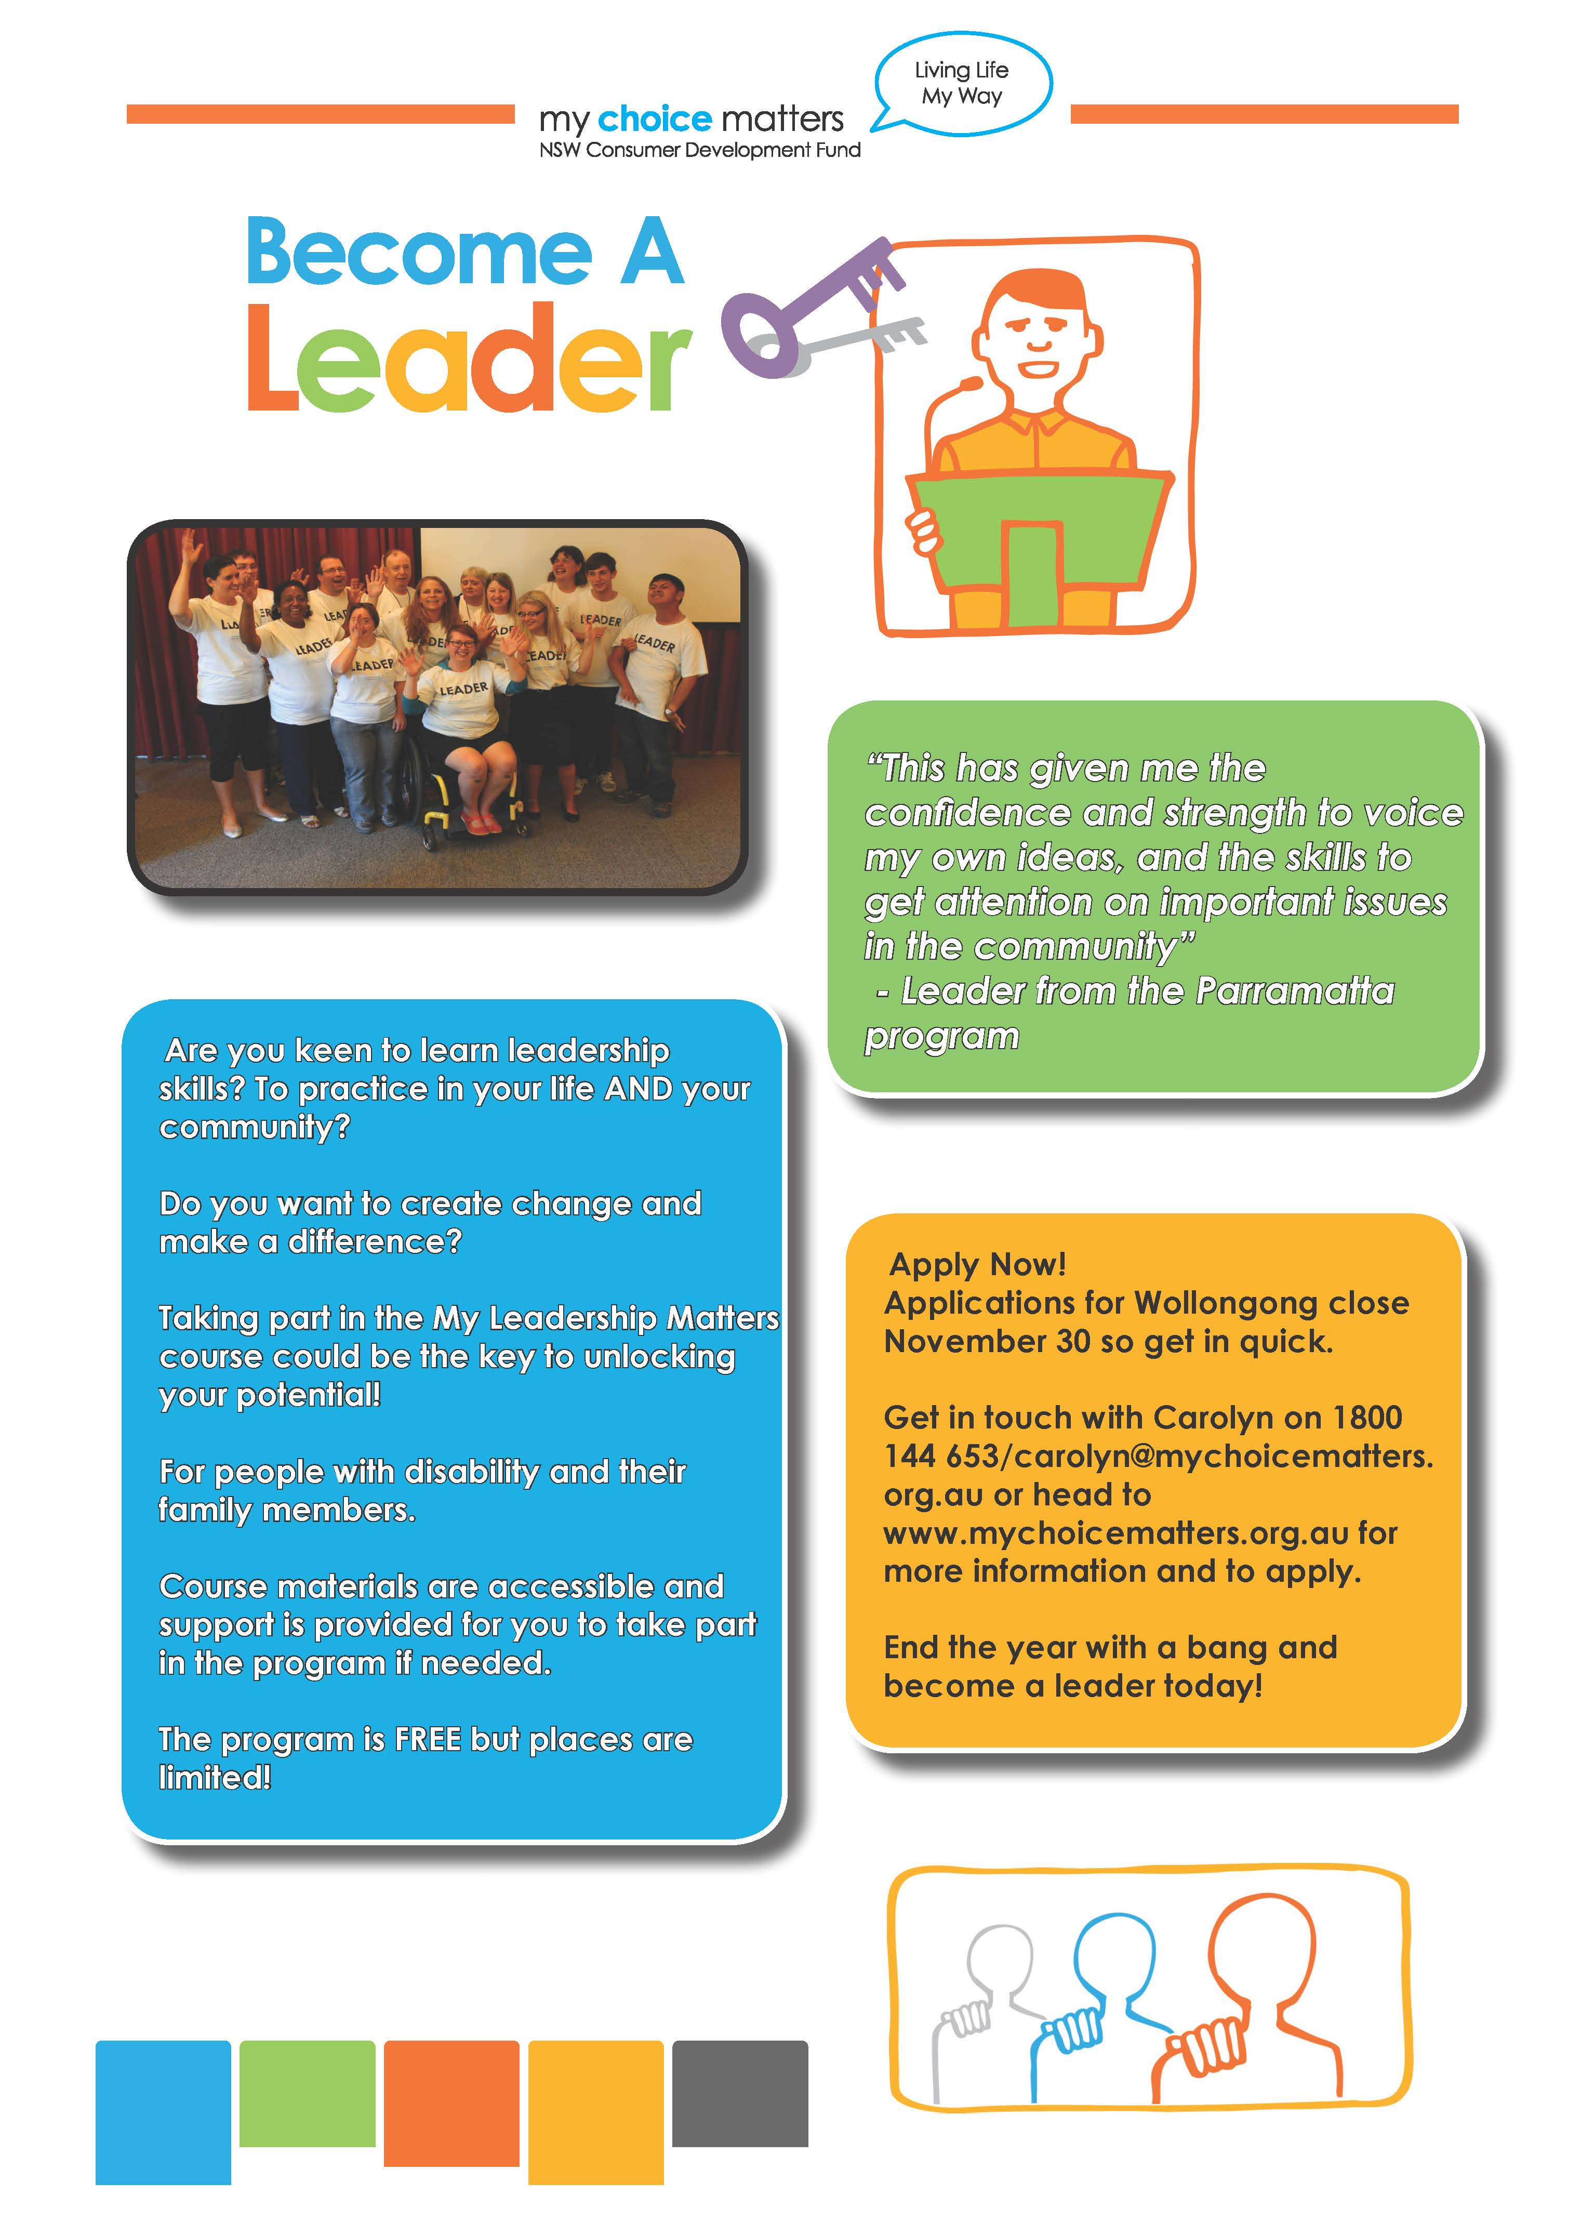




Disclaimer: Havenlee School advertises in this column as a service to parents. Havenlee School does not endorse, sponsor or accept responsibility for the management or organisation of the advertised events or services.

