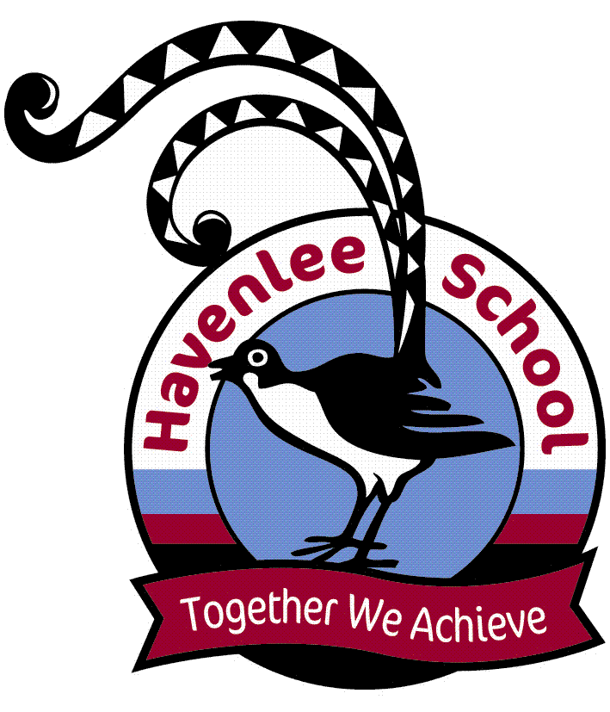
From the Principal

It has been a busy two weeks at Havenlee School with all class’s completing lots of work and the coming weeks will be just as busy. Dates to remember:

- 29 November – Year 12 Graduation Dinner.
- 7 December – Awards Assembly starting at 11:30.
- 19 December – Students last day of school.

Katrina Eyland
School Principal

Up and Coming Events

Term 4 Week 8
29 November Hydro
Year 12 Graduation Dinner
1 December Hydro
Term 4 Week 9
6 December Hydro
P & C meeting 9:15
7 December Awards Assembly 11:30
8 December Hydro

RAP Awards
(Really Awesome Person)

Congratulations to the following students who received RAP awards.

1P Kiani, Martin, Zahra, Daniel, Xavier
2P Emme, Cameron, Kaylen
4M Charlee, Jessica, Faith, Zeke
5M Emily, Dayna, Joshua, Ben, Tobias, Eamon, Leilani
6S Lily, Ashlyn, Shantelle,
7S Hayden, Heath, Buddy
8S Tim, Joshua, Declan, Clayton, Joshua, Shae-Lynn

Canteen News
The canteen will be closed on the following dates

Wednesday 30th November
Mon 12th – Fri 16th December
Community News

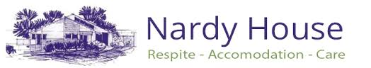

Nardy House provides permanent accommodation and respite to people with profound physical disabilities in the Bega area, with
- Support and advocacy to people with profound disabilities and their carers.
- Therapy and hydrotherapy to assist people with profound disabilities. This facility is at the design stage.
- Specialised respite in a world class facility offered twenty-four hours/ seven days a week.
- A “hands -on” Registered Nurse as our Respite Coordinator.
- Support nursing staff in the respite facility who provide nursing level of care around the clock for very high level support needs
- Support and advocacy to local and regional carers
- The development of promotional material related to fund raising and assisting the building programme.
You can contact us at
Street Address: Nardy House, 11520 Princes Hwy, Quaama NSW 2550
Postal Address: Nardy House, P.O. Box 387, Quaama NSW 2550
Phone: 02 64938120





Care Flight Christmas Magic Mania will be held at
Sydney Olympic Sports Centre, Homebush Bay, 17
December. They are offering free tickets (valued at $60
which also includes free parking) to families, each ticket
admits up to 10 children and carer’s free. There is three
different session times available, 12:30pm, 2:30pm,
4:30pm. If you would like a ticket, please call the school
office on 44213777.

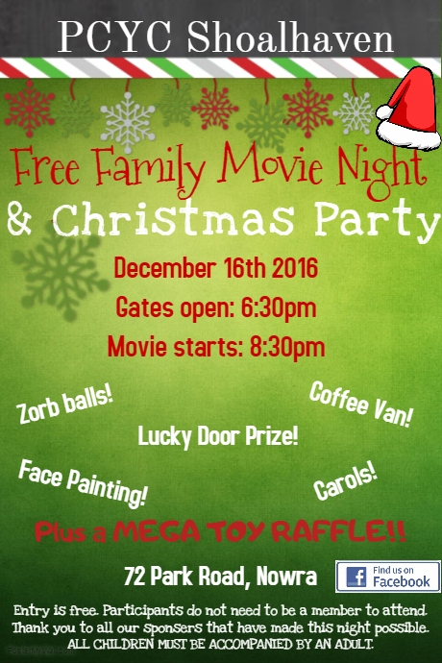

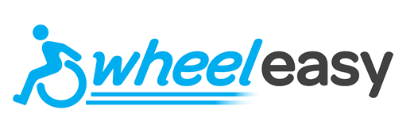

WheelEasy's aim is to create better access to
leisure activities for wheelchair users and
their family & friends.
As a wheelchair user I know that if I can't get
somewhere, then everyone with me has the
same problem! So WheelEasy is not just for
wheelchair users, but also for everyone who
wants to enjoy life to the full with them.
One of the biggest problems has always been
finding the right information. So, we're
launching this month with our first project - the
WheelEasy Access Information website at
www.wheeleasy.org.au.

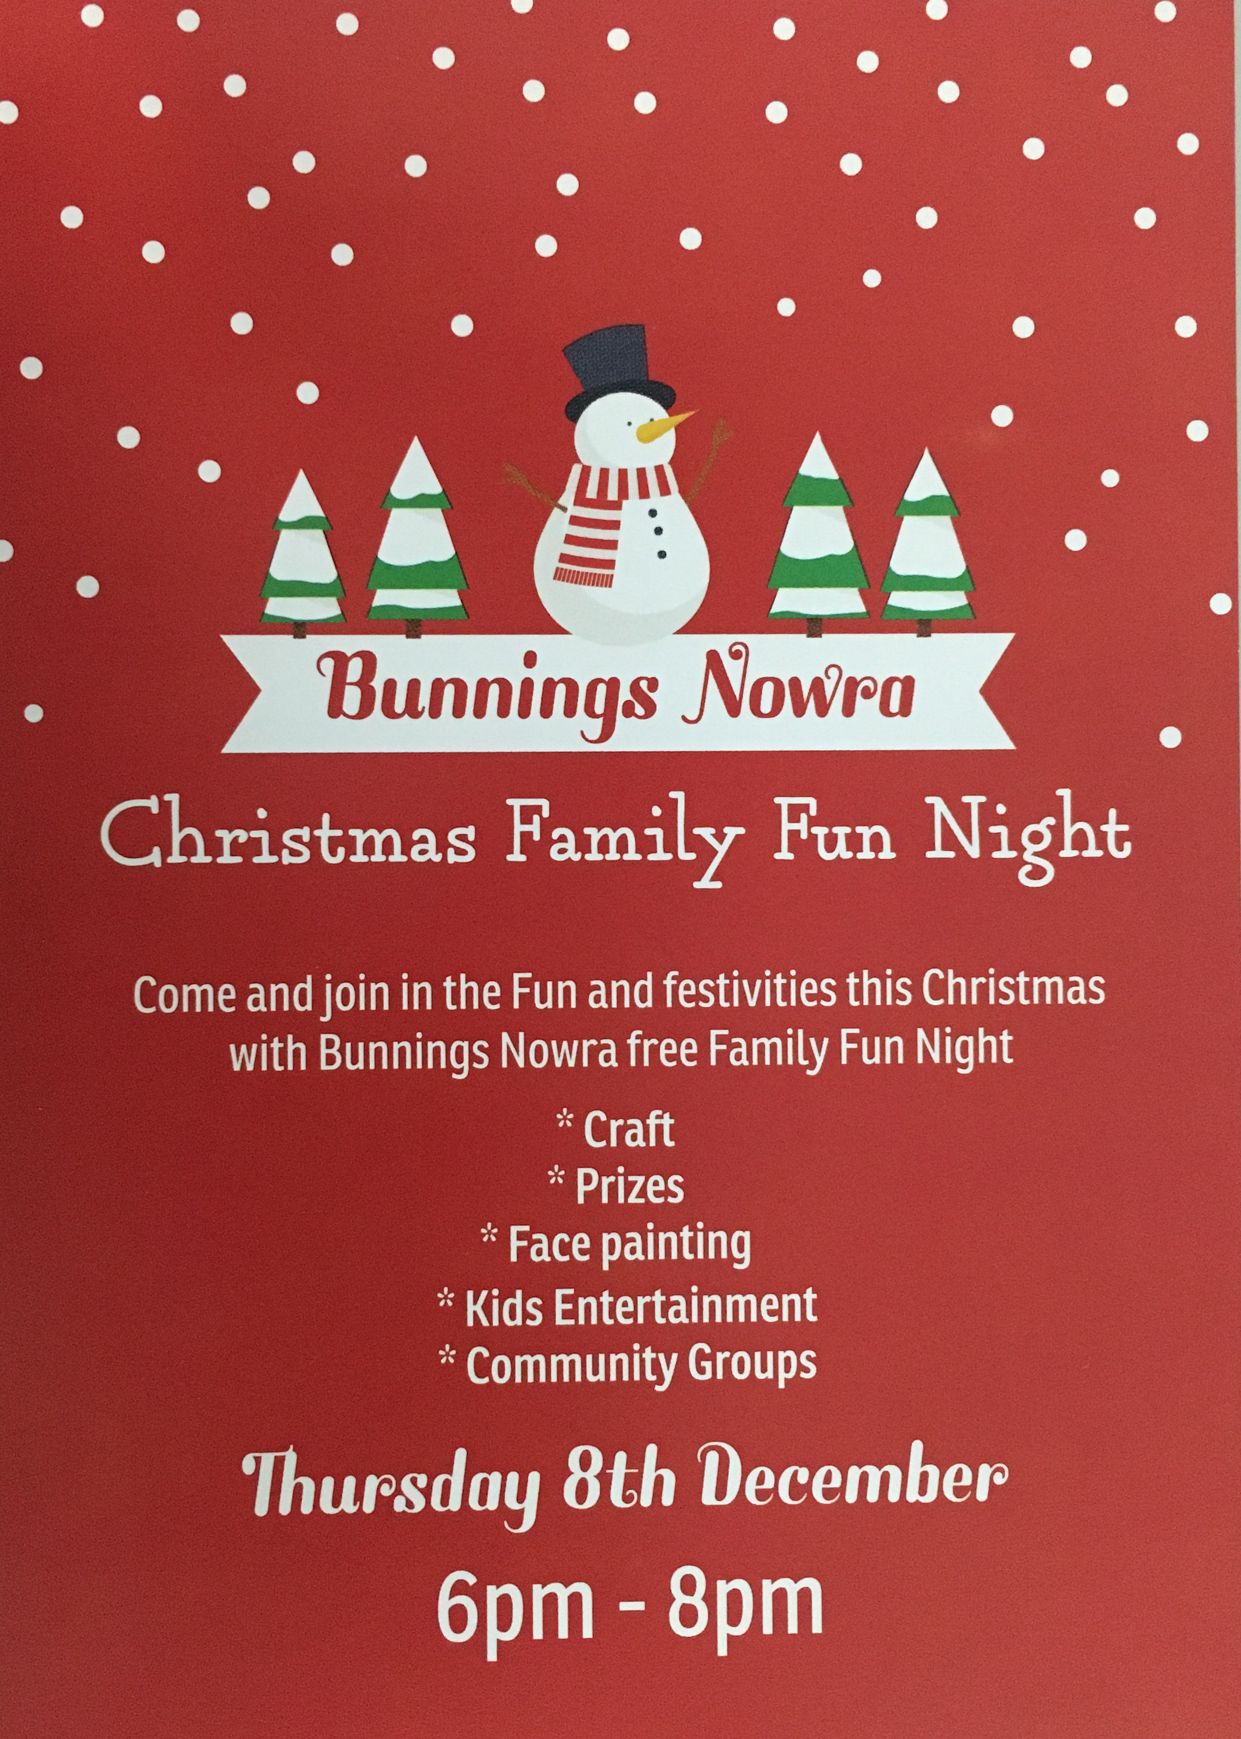

Disclaimer: Havenlee School advertises in this column as a service to parents. Havenlee School does not endorse, sponsor or accept responsibility for the management or organisation of the advertised events or services.

