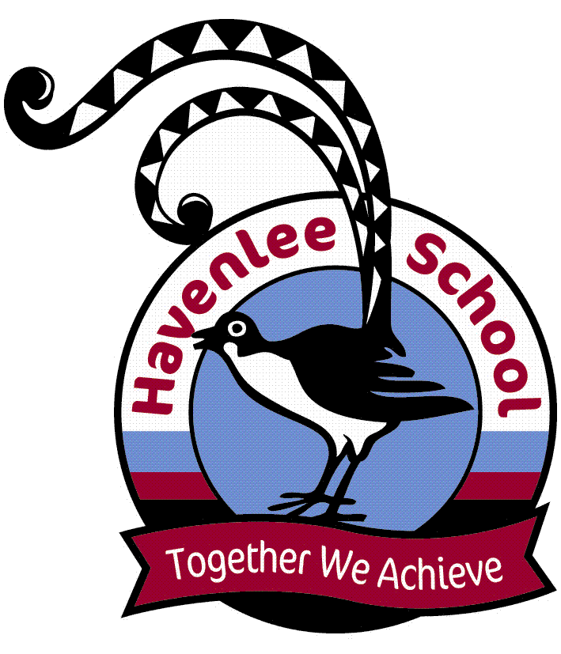
From the Principal

Outdoor Gym
Early this week we received a cheque from DASI for $5000 to put towards the landscaping for the outdoor gym. This is in addition to the $8000 given to us earlier in the year by the Veolia Mulwaree Trust, $5000 from School to Work Program and $10000 from Havenlee P&C. We are extremely grateful for these donations. As a result, we are starting the process of clearing the area and ordering the products (exercise equipment and synthetic grass, concreting and softfall). Stay tuned for more updates on this exciting new project.

Parent Survey
We have organised parents/carers to have access to a survey so you can let us know how you feel about Havenlee School. I encourage you to take the time to fill it out so your ideas/ thoughts can guide us in planning for the coming year. We always value your input on how we can make Havenlee a better place for your children.

Term 4
School Returns for students on Monday 10 October. I hope you have a safe and enjoyable holiday.

Future Dates for the Diary
Monday 17 October LMBR
(new computer system) goes “live”
Tuesday 18 October Shoalhaven Disability Expo
Thursday 3 November Post School Options Excursion (Stage 6)
Tuesday 29 November Graduation Dinner
Wednesday 7 December
Havenlee Presentation Assembly
Monday 19 December Last Day for Students

Katrina Eyland
School Principal

Up and Coming Events
Term 3 Week 10
20 September Hydro
22 September Hydro
Term 4 Week 1
10 October Student return to school
11 October Hydro
13 October Hydro

RAP Awards
(Really Awesome Person)
Congratulations to the following students who received RAP awards.
1P Kiani, Martin, Jordan, Zahra
2P Daniel, Liam, Bailey, Kaylen
3P Kelvin, Harley
4M Charlee, Jessica, Tim, Faith, Zeke
5M Dayna, Joshua, Ben, Tobias, Eamon, Leilani, Flo
6S Ashlyn, Shantelle, Lily
7S Hayden
8S Tim, Joshua, Declan, Clayton, Shae-Lynn, Joshua

The Partners in Learning parent feedback survey
This Term, our school will be participating in the Partners in Learning parent survey, another part of the Tell Them From Me suite of surveys (student, teacher and parent surveys) on student engagement. The survey asks parents and carers questions about different factors that are known to impact on student wellbeing and engagement.
Running this survey will help our school understand parents’ and carers’ perspectives on their child’s experience at school. These include: communication between parents/carers and staff, activities and practices at home and parent/carer views on the school's support of learning and behaviour. This valuable feedback will help our school make practical improvements.
The survey is conducted entirely online at home or on public computers. The survey will typically take 15 minutes or less to complete and is completely confidential. The parent survey will be conducted between 22 August and 21 October. Participating in the survey is entirely voluntary, however, your responses are very much appreciated.
More information about the survey is available at: http://surveys.cese.nsw.gov.au/information-for-parents
"For parents to access this survey and provide confidential feedback to the school, please go to
https://nsw.tellthemfromme.com/vd9vy​
Havenlee School values your comments. This information is useful and is greatly appreciated.

CANTEEN NEWS
The canteen will be CLOSED on
The last day of term, Friday 23 September. The canteen will not reopen until Wednesday 19 October in the second week of term 4.

Disclaimer: Havenlee School advertises in this column as a service to parents. Havenlee School does not endorse, sponsor or accept responsibility for the management or organisation of the advertised events or services.



